**PEAS BRIDGE HIGH SCHOOL.**

**MITOOMA.**

**S 3 END OF TERM 1I, 2023**

**ENGLISH LANGUAGE 112**

**2 hours**

**NAME: ………………………………………………………………STREAM ...........................**

***SECTION A***

*Supply a suitable adjective to complete the following sentences*

1. I used to play dodgeball. It was an ………………….. game.
2. My favourite teacher, Ms Nakalemebe, was the …………………… of all.
3. I used to travel to the village where I encountered the most ………………experience.
4. On my fifth birthday, we enjoyed a ………………….. meal. My mother bought me …………… shoes and a ………………………… cake.
5. Our Nursery school had a ………………………. Compound with ……………….. trees, ………………….. flowers and …………………… grass.

***Fill in the gaps with the suitable adverbs from the following table***

|  |  |  |  |  |
| --- | --- | --- | --- | --- |
| **Ruthlessly** | **Blissfully** | **profusely** | **Incessantly** | **sternly** |
| **Clumsily** | **Hysterically** | **anxiously** | **Expectantly** | **furiously** |

1. Mr Magogo was such a tough teacher who used to cane us ………………………………
2. When Sports Day ended, we waited for the results ………………………………………..
3. My father promised me a toy but I had to work for it ……………………………………..
4. Everybody loved teacher Cherop so much that they would welcome her …………………
5. One day, my two friends fought after arguing ……………………………………………..
6. Our housemaid used to break utensils while washing them ……………………………….
7. Ofwono was such an ill-mannered boy that the teacher warned him ……………………..
8. Scarcely had Namata had an accident when she bled ……………………………………..
9. No sooner had they told me to do the work than I mumbled ……………………………..
10. Oluka used to crack jokes and make us laugh ……………………………………………..

***SECTION B***

*Read the following passage and answer the questions that follow*

*From Kossoh Town Boy, the true story of the childhood, in Freetown, Sierra Leone, of a man who is now an eminent surgeon.*

The more I try to recall the earliest impressions of my childhood, the more surprising the result becomes. I can see myself as a new-born baby, barely a day old, possibly a few hours old, receiving the vigorous attentions of my maternal grandmother.

She sits on a stool in the middle of an airy bedroom, a proud contented look on her face. On the floor beside her is a broad metal basin, more than two feet in diameter, and about eight inches deep. This is half-filled with warm soapy water. Across her knees is spread a waterproof sheeting. On this she supports me with her left hand, while with the other she anoints me from head to foot with a rich lather of native black soap. My eyes are tightly shut, my mouth wide open in a yell of protest.

As she vigorously rubs away, the yelling continues, and the roomful of women look on approvingly.

‘*Man pikin don cam. Allelujah!’* (Unto us a son is born!), they cry.

Having thoroughly lathered me, my grandmother dips me into the basin of water, and scoops the contents all over me. As the water runs into my mouth, I shut up sharp. Half choking, I gulp hard, swallow, and let out a yell of even louder protest. My grandmother ignores me, and carries on with her task. Then she lifts me on to her lap, and towels me briskly.

The assembled ladies take a look at my flat little face with its squashed nose and *puffy* little eyes, and say admiringly:

‘Just like his daddy!’

There is a coal pot, that is, an open *charcoal brazier*, burning brightly near at hand. From it someone lifts a small oval stone about six inches long, worn smooth. Normally it is the ‘daughter stone’ which is used to grind pepper, spices, egusi, lokos, and other cooking ingredients on a large flat mother stone. Now, it has been washed and brought to a red heat, and so thoroughly *sterilized.* Some water is poured on it, causing a fierce sizzle: but it still remains dull red-hot.

A little piece of clean cotton cloth is dipped in a glass of water, squeezed out, and pressed on the stone. It is then lifted up, allowed to cool a bit, and then applied firmly to the end of the birth cord dangling from my navel. Thus sterilized, the cord is folded and bandaged into position. This will be repeated daily until it drops off.

‘The *agbo,* don’t forget the *agbo!’* they remind her, as the door opens, and somebody comes in with a small half-gourd full of a special kind of herbal tea. My grandmother tastes it to check the temperature, and then lifting me up gently she pulls her skirt well up her *plump* left thigh.

She lays me along this limb, with my head over her knee, her left arm supporting my back and head and holding the gourd, some of the contents of which she pours into her right hand held *cupped* against my mouth. She *heaves* in a quantity of the *liquid* smartly as I open my mouth to cry. I choke, swallow instinctively, take a good breath and open my mouth wide for a tremendous yell. But she is ready, and immediately I receive another *dose* into the back of my throat. I *splutter,* shut my eyes tight, kick out, go stiff with anger and open wide for a truly nasty yell of protest; but again she is ready and heaves in the right quantity of *agbo* with practical aim. So the *duel* continues, each yell stopped by a dose of tea, followed by a swallow, a holding of breath, and an attempt at an even louder yell, which meets with the same fate, until the gourd is empty. So I have my first drink in this world.

***Questions***

1. From your own experience, do you think it is likely for anyone to remember as far back as the day he was born? What other explanation do you think of for the ‘memory’ described in this passage?

……………………………………………………………………………………………………………………………………………………………………………………………………………………………………………………………………………………………………………………………………………………………………………………(2 mks)

1. What purpose was the waterproof sheeting to serve?

…………………………………………………………………………………………………………………………………………………………………………………… (1 mk)

1. What was the purpose of heating the ‘daughter stone’ and what was it used for?

…………………………………………………………………………………………………………………………………………………………………………………………………………………………………………………………………………………… (1 mk)

1. Explain the meaning of the following expressions as used in the passage:
2. …. *the more surprising the result becomes…*

…………………………………………………………………………………………………………………………………………………………………… (1 mk)

1. ….. *half-chocking …..*

…………………………………………………………………………………………………………………………………………………………………… (1 mk)

1. … *my grandmother ignores me* …..

…………………………………………………………………………………………………………………………………………………………………… (1 mk)

1. …. *Towels me briskly …..*

…………………………………………………………………………………………………………………………………………………………………… (1 mk)

1. ….. *to check the temperature ….*

…………………………………………………………………………………………………………………………………………………………………… (1 mk)

1. …. *So the duel continues …..*

…………………………………………………S………………………………………………………………………………………………………………… (1 mk)

***ANSWER THESE ON SEPARATE ANSWER SHEETS***

*Answer* ***TWO*** *questions in all.*

*Section* ***A*** *is* ***compulsory****. Choose* ***one*** *other question from Section* ***B***

***SECTION A (20 MARKS)***

***Use 150-200 words (one page)***

1.In Bukomansimbi village, there were two children who used to play together but at times they would fight and end up reconciling just by-word exchange. 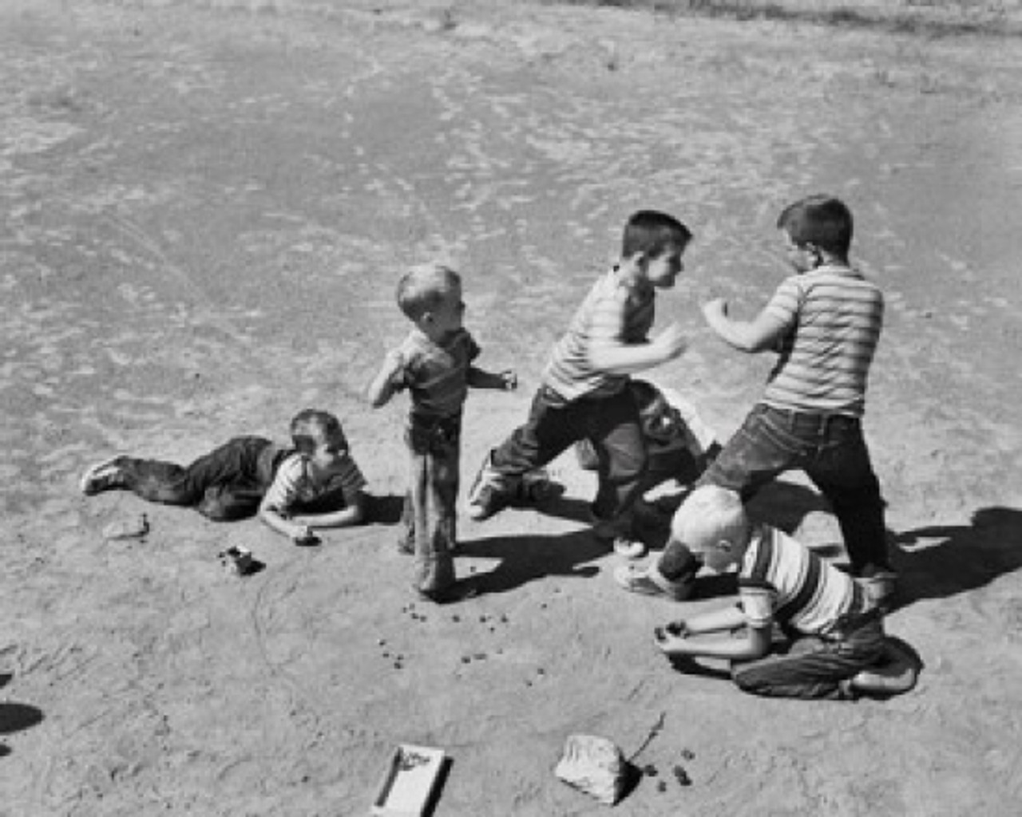

Imagine, it were your friend whom you have hurt while playing. Write a dialogue between you and your

friend.

***SECTION:B***

Choose only **one** topic and write a composition of **350-400** words

**EITHER**

2.Narrative about your favorite game.

**OR**

Write a story ending……………………………I am what I am because of those words.

**END**